Form Designs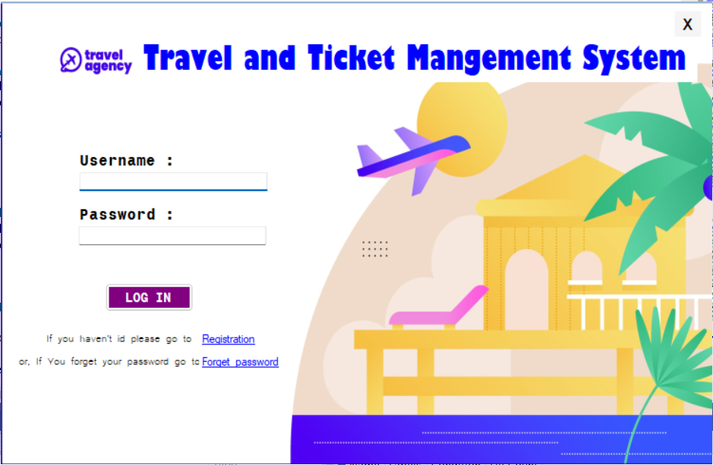
Fig 07: Log in page (Actor- Admin, Agent, Customer).hasib
Note: If the username or password does not match, an error message will be displayed.
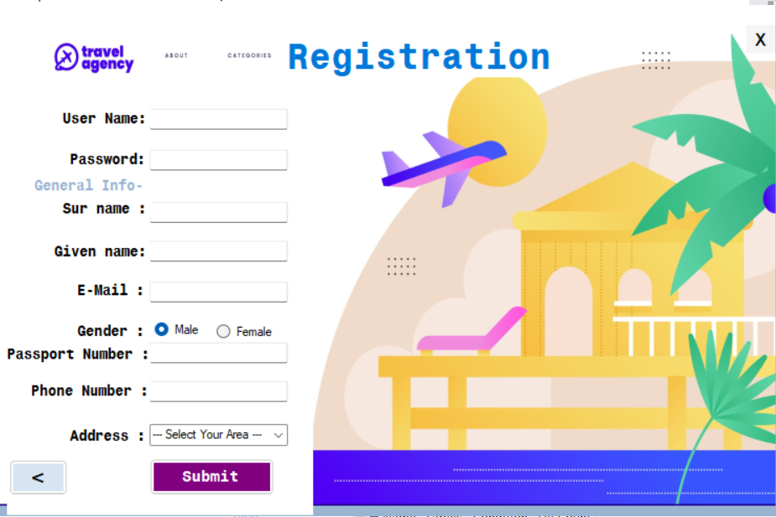
Fig 08: Registration page (Actor- Admin, Agent, Customer). hasib
Note: If they miss any questions, an error message will be displayed.
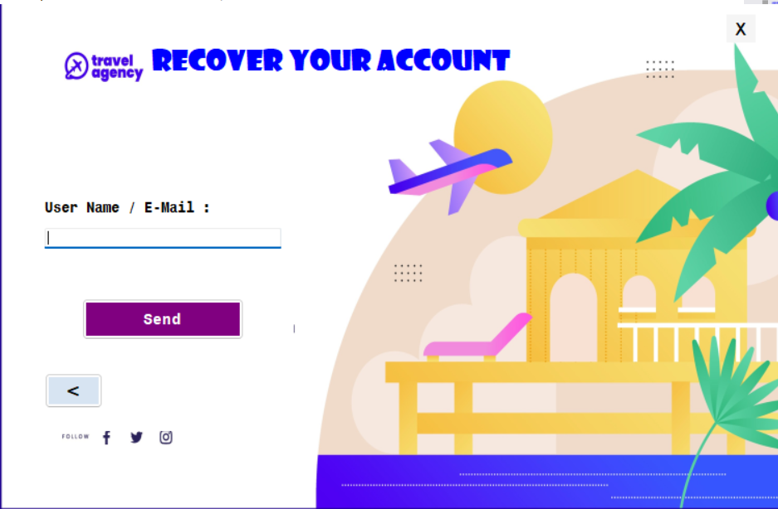
Fig 09: Check username / email address, if forget the password (Actor- Admin, Agent, Customer). hasib
Note: If the username or email address does not match, an error message will be displayed.
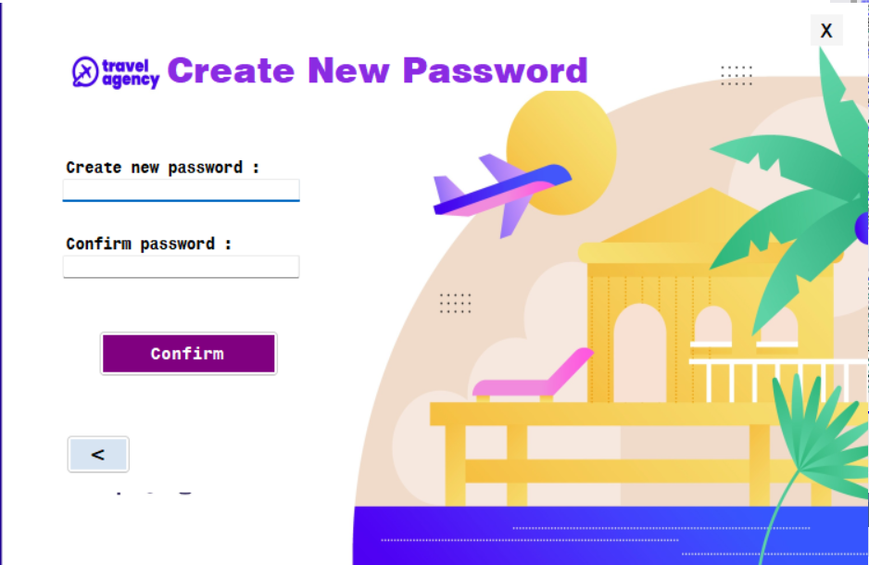
Fig 10: Create new password page. hasib
Note: Have to use same password twice.
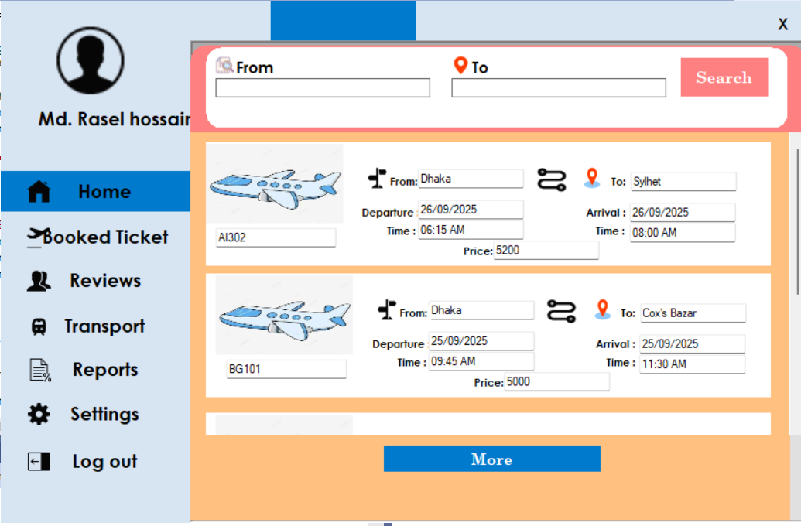
Fig 11: Home page (Actor- Agent, Customer). hasib
Note: If click on more it will generate more tickets and by scrolling it also showcase more tickets.
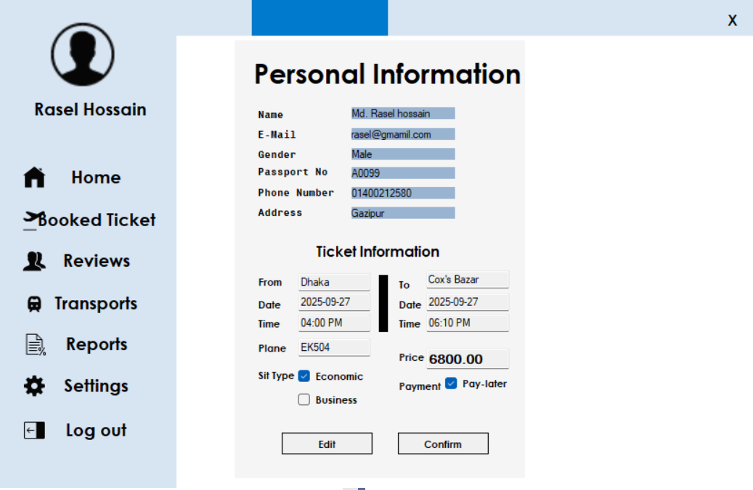
Fig 12: Ticket & Personal information summary page (Actor- Customer). hasib
Fig 13: Ticket & Personal information summary page (Actor- Agent).
Note: When an agent clicks on a preferred ticket, the system will display the general user information, ticket details, and ticket numbers. This feature is available only for agents, who can book up to 10 tickets at once. The general information can be edited as needed.
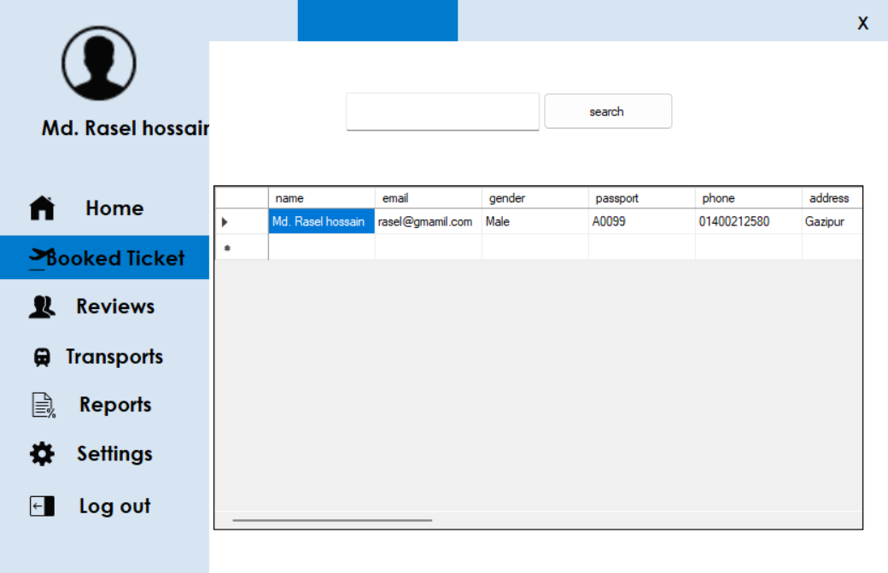
Fig 14: Tickets Booked History page (Actor- Agent, Customer).Jitu
Note: Check the previous Booking History.
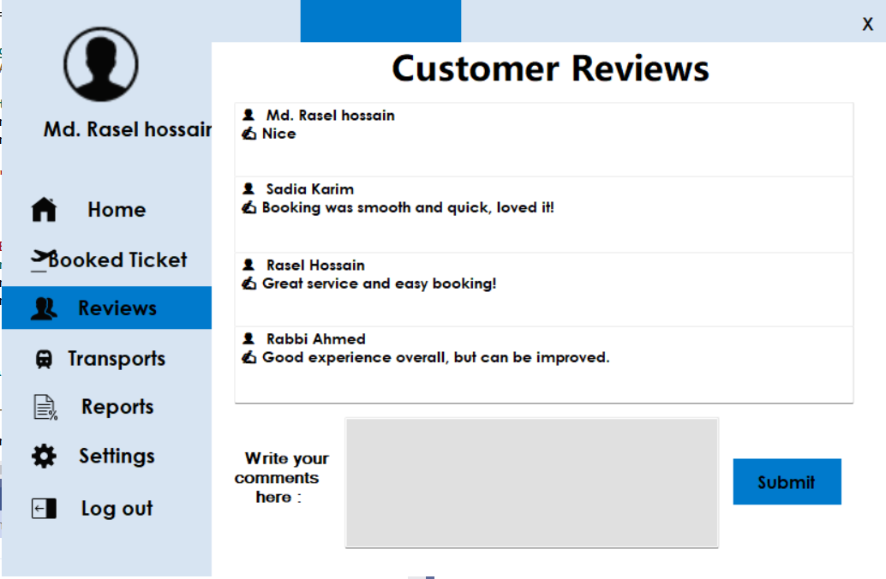
Fig 15: Customer Reviews page(Actor- Agent, Customer). Jitu
Note: User Can see the others reviews and can provide their own review.
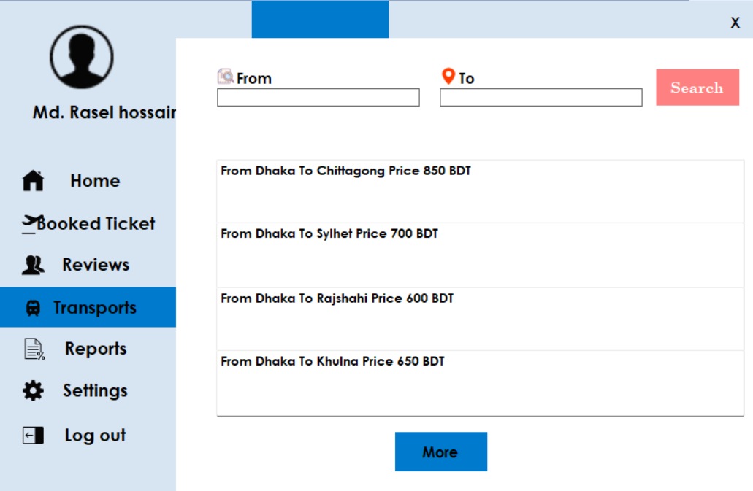
Fig 16: Transports cost finding page (Actor- Agent, Customer). Jitu
Note: Customers can see the transports cost between two cities and can search for their required city.
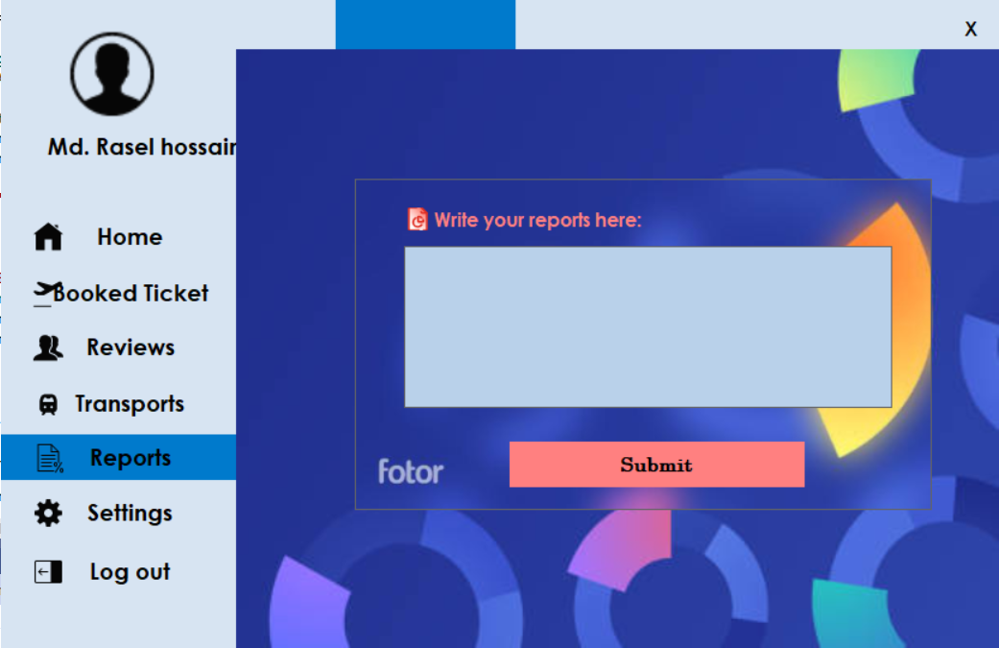
Fig 17: Reports for any problematic issues page (Actor- Agent, Customer). Jitu
Note: User can make a report for any problem.
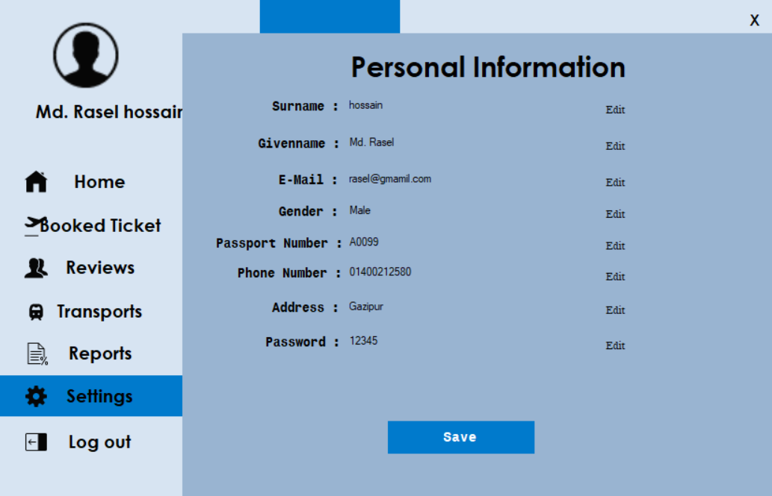
Fig 18: Personal information page (Actor- Agent, Customer). Jitu
Note: User can see their personal information and can change any information by click edit buttons.

